The Balance Sheet (Also known as a “Statement of Financial Position”)

*Sources:*

[*https://nonprofitsassistancefund.docalytics.com/v/balance-sheet-cheat-sheet-2014*](https://nonprofitsassistancefund.docalytics.com/v/balance-sheet-cheat-sheet-2014)[*http://www.nonprofitfinancefund.org/sites/default/files/22-1_christopher_why-do-balance-sheets-matter1.pdf*](http://www.nonprofitfinancefund.org/sites/default/files/22-1_christopher_why-do-balance-sheets-matter1.pdf)

**Definition**: A statement of the assets, liabilities, and capital of a business or other organization at a particular point in time, detailing the balance of income and expenditure over the preceding period.

**Overview:** The balance sheet - also called the Statement of Financial Position - serves as a snapshot, providing the most comprehensive picture of an organization's financial situation. It reports on an organization's assets **(what is owned) and liabilities (what is owed)**. The net assets (also called equity, capital, retained earnings, or fund balance) represent the sum of all annual surpluses or deficits. The balance sheet also indicates an organization's liquidity by communicating how much cash an organization has at present and what assets will soon be available in the form of cash.

**BALANCE SHEET EXAMPLE 1**

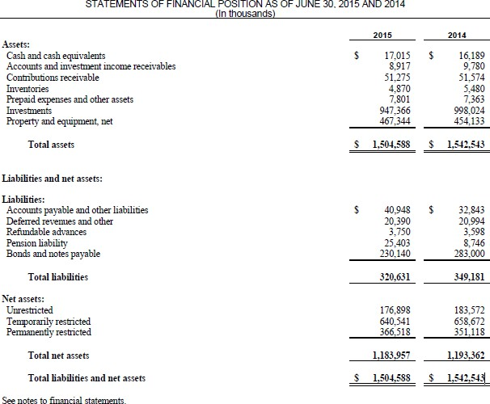

**BALANCE SHEET EXAMPLE 2**

**CIDER HILL PLAYERS**

STATEMENT OF FINANCIAL POSITION DECEMBER 31, 2009 AND 2008

|  |  |  |  |
| --- | --- | --- | --- |
| **ASSETS** | | **2009** | **2008** |
| CURRENT ASSETS | |  |  |
| Cash | | $ 453,728 | $ 492,511 |
| Investments | | 144,616 | 144,113 |
| Accounts receivable | | 9,121 | 2,400 |
| Grants receivable | | 41,759 | 54,167 |
| Prepaid expenses | | 1,874 | 8,743 |
| Total current assets | | 651,098 | 701,934 |
| PROPERTY AND EQUIPMENT | |  |  |
| Equipment | | 33,794 | 38,363 |
| Production sets, costumes | | 53,000 | 53,000 |
| Leasehold improvements | | 15,082 | 15,082 |
| Less: Accumulated depreciation | | (95,578) | (100,120) |
| Property and equipment (PE), net | | 6,298 | 6,325 |
| OTHER ASSETS | |  |  |
| Security deposit | 23,020 | | 22,260 |
| Total other assets | 23,020 | | 22,260 |
| **TOTAL ASSETS** | $ 680,416 | | $ 730,519 |
| **LIABILITIES AND NET ASSETS** |  | |  |
| CURRENT LIABILITIES |  | |  |
| Accounts payable | 662 | | 5,012 |
| Unearned revenue | 5,222 | | 31,600 |
| Line of credit, payable | 25,000 | | 20,000 |
| Total current liabilities | 30,884 | | 56,612 |
| LONG-TERM LIABILITIES |  | |  |
| Total liabilities | 30,884 | | 56,612 |
| NET ASSETS |  |  |  |
| Unrestricted | 548,667 | | 491,840 |
| Unrestricted, board designated | 50,000 | | 50,000 |
| Temporarily restricted | 50,865 | | 132,067 |

Total net assets 649,532 673,907

**TOTAL LIABILITIES $ 680,416 $ 730,519 NET ASSETS NET ASSETS**