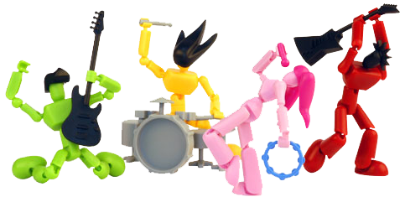

Join us at:   
Address line 1 Address line 2  
Phone: 555-555-55555  
Fax: 555-555-5555  
www.invitationtemplatesstore.com

*“We are going to celebrate and enjoy ROCK music party here and this is an open invitation for all who want to enjoy best music of the region”*

**JAM in JAVA**   
will play ROCK n ROLL music for you

Come & Enjoy  
MUSIC PARTY INVITATION