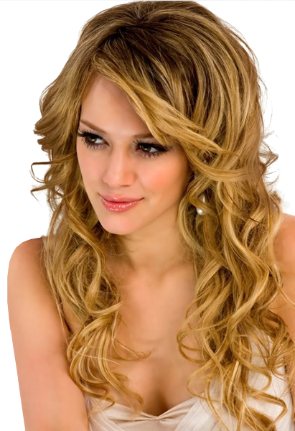

**20% OFF**

**Women’s cut & Blow Dry**

**40% OFF**

**Perm’s**

**40% OFF**

**Foil Hilites**

**20% OFF**

**All Hair Products**

Escape Salon and Hair Care

Special Offers  
LIMITED TIME  
Every First Week of the Month

555-555-55555  
Sheridan Center, 2225 Erin Mills Parkway