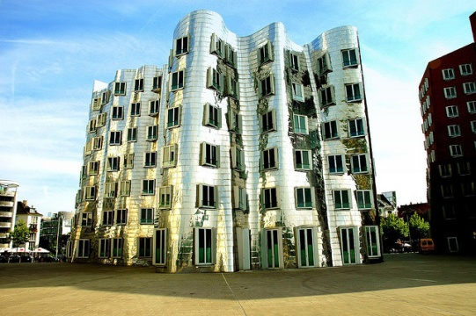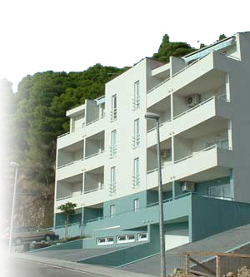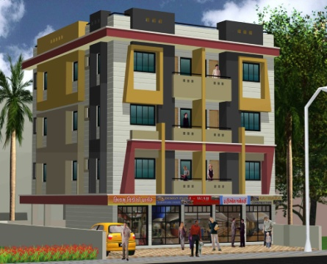Sdxf

Apartment for Rent

**Contact Information:**

18293 Sunset Circles

Ocean Beach, CA 92116

Phone: 555-555-555555

www.example.com

$1,000.00 monthly plus 1 month security  
Tenant pays own heat  
section 8 welcome

**Available: Immediately**

Lawndale Area

1st floor apartment, Newly rehabbed  
7 rooms  
3 bedrooms  
Hardwood floors, tiles and ceiling fans