**Photography Flyer**

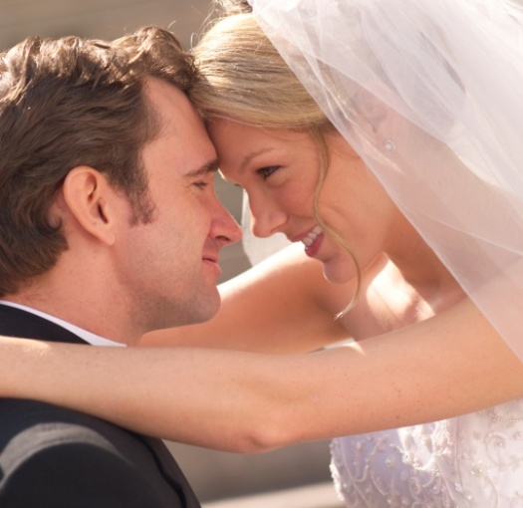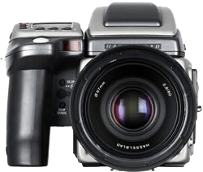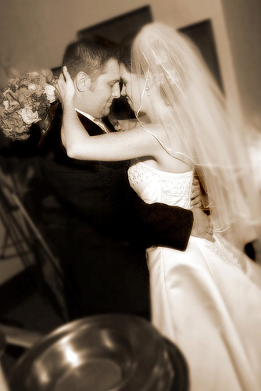

-------------------------------------------------------------------------------------------------------------------------------------------------------------------------------------------------------------------------------------------------------------------------------------------------------------------------------------------------------------------------------------------------------------------------------------------------------------------------------------------------------------------------------------------------------------------------------------------------------------------------------------------------------------------------------------------------------------------------------------------------------------------------------------------------------------------------------------------------------------------------------------------------------------------------------------------------------------------------------------------------------------------------------------------------------------------------------------------------------------------------------------------------------------------------------------------------------------------------------------------------------------------------------------------------------------

**The Official Photographer of the CB&I Tri**

Contact Trucker Photography

To photograph your next even!

email@example.com

**555-555-5555**