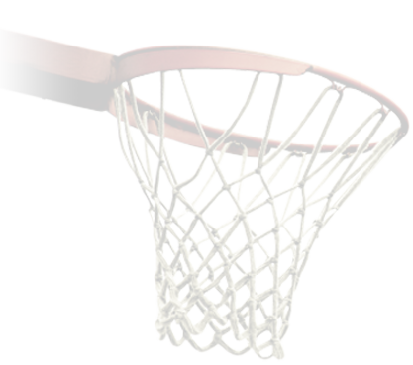

**Packing List**

**Additional Notes:**

_______________________________________________________________________________________________________________________________________________________________________________________________________________________________________________________________________________________________________________________________________________________________________________________________________________________________

|  |  |  |
| --- | --- | --- |
| Items Name | How Many to Pack? |  |
|  |  |  |
|  |  |  |
|  |  |  |
|  |  |  |
|  |  |  |
|  |  |  |
|  |  |  |
|  |  |  |
|  |  |  |
|  |  |  |
|  |  |  |
|  |  |  |
|  |  |  |
|  |  |  |
|  |  |  |
|  |  |  |
|  |  |  |
|  |  |  |
|  |  |  |
|  |  |  |
|  |  |  |
|  |  |  |
|  |  |  |
|  |  |  |
|  |  |  |
|  |  |  |
|  |  |  |
|  |  |  |
|  |  |  |
|  |  |  |
|  |  |  |