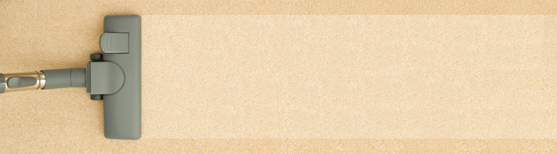

**General Checklist**

|  |  |
| --- | --- |
| A |  |
|  | |
| B |  |
|  | |
| C |  |
|  | |
| D |  |
|  | |
| E |  |
|  | |
| F |  |
|  | |
| G |  |
|  | |
| H |  |
|  | |
| I |  |
|  | |
| J |  |
|  | |
| K |  |
|  | |
| L |  |
|  | |
| M |  |
|  | |
| N |  |
|  | |
| O |  |
|  | |
| P |  |
|  | |
| Q |  |
|  | |
| R |  |
|  | |
| S |  |
|  | |
| T |  |
|  | |
| U |  |
|  | |
| V |  |
|  | |
| W |  |
|  | |
|  |  |

|  |  |
| --- | --- |
| 1 |  |
|  | |
| 2 |  |
|  | |
| 3 |  |
|  | |
| 4 |  |
|  | |
| 5 |  |
|  | |
| 6 |  |
|  | |
| 7 |  |
|  | |
| 8 |  |
|  | |
| 9 |  |
|  | |
| 10 |  |
|  | |
| 11 |  |
|  | |
| 12 |  |
|  | |
| 13 |  |
|  | |
| 14 |  |
|  | |
| 15 |  |
|  | |
| 16 |  |
|  | |
| 17 |  |
|  | |
| 18 |  |
|  | |
| 19 |  |
|  | |
| 20 |  |
|  | |
| 21 |  |
|  | |
| 22 |  |
|  | |
| 23 |  |
|  | |
|  |  |