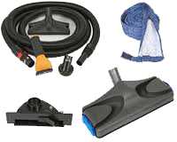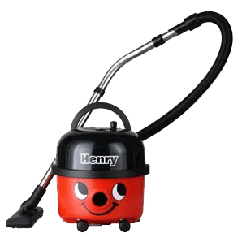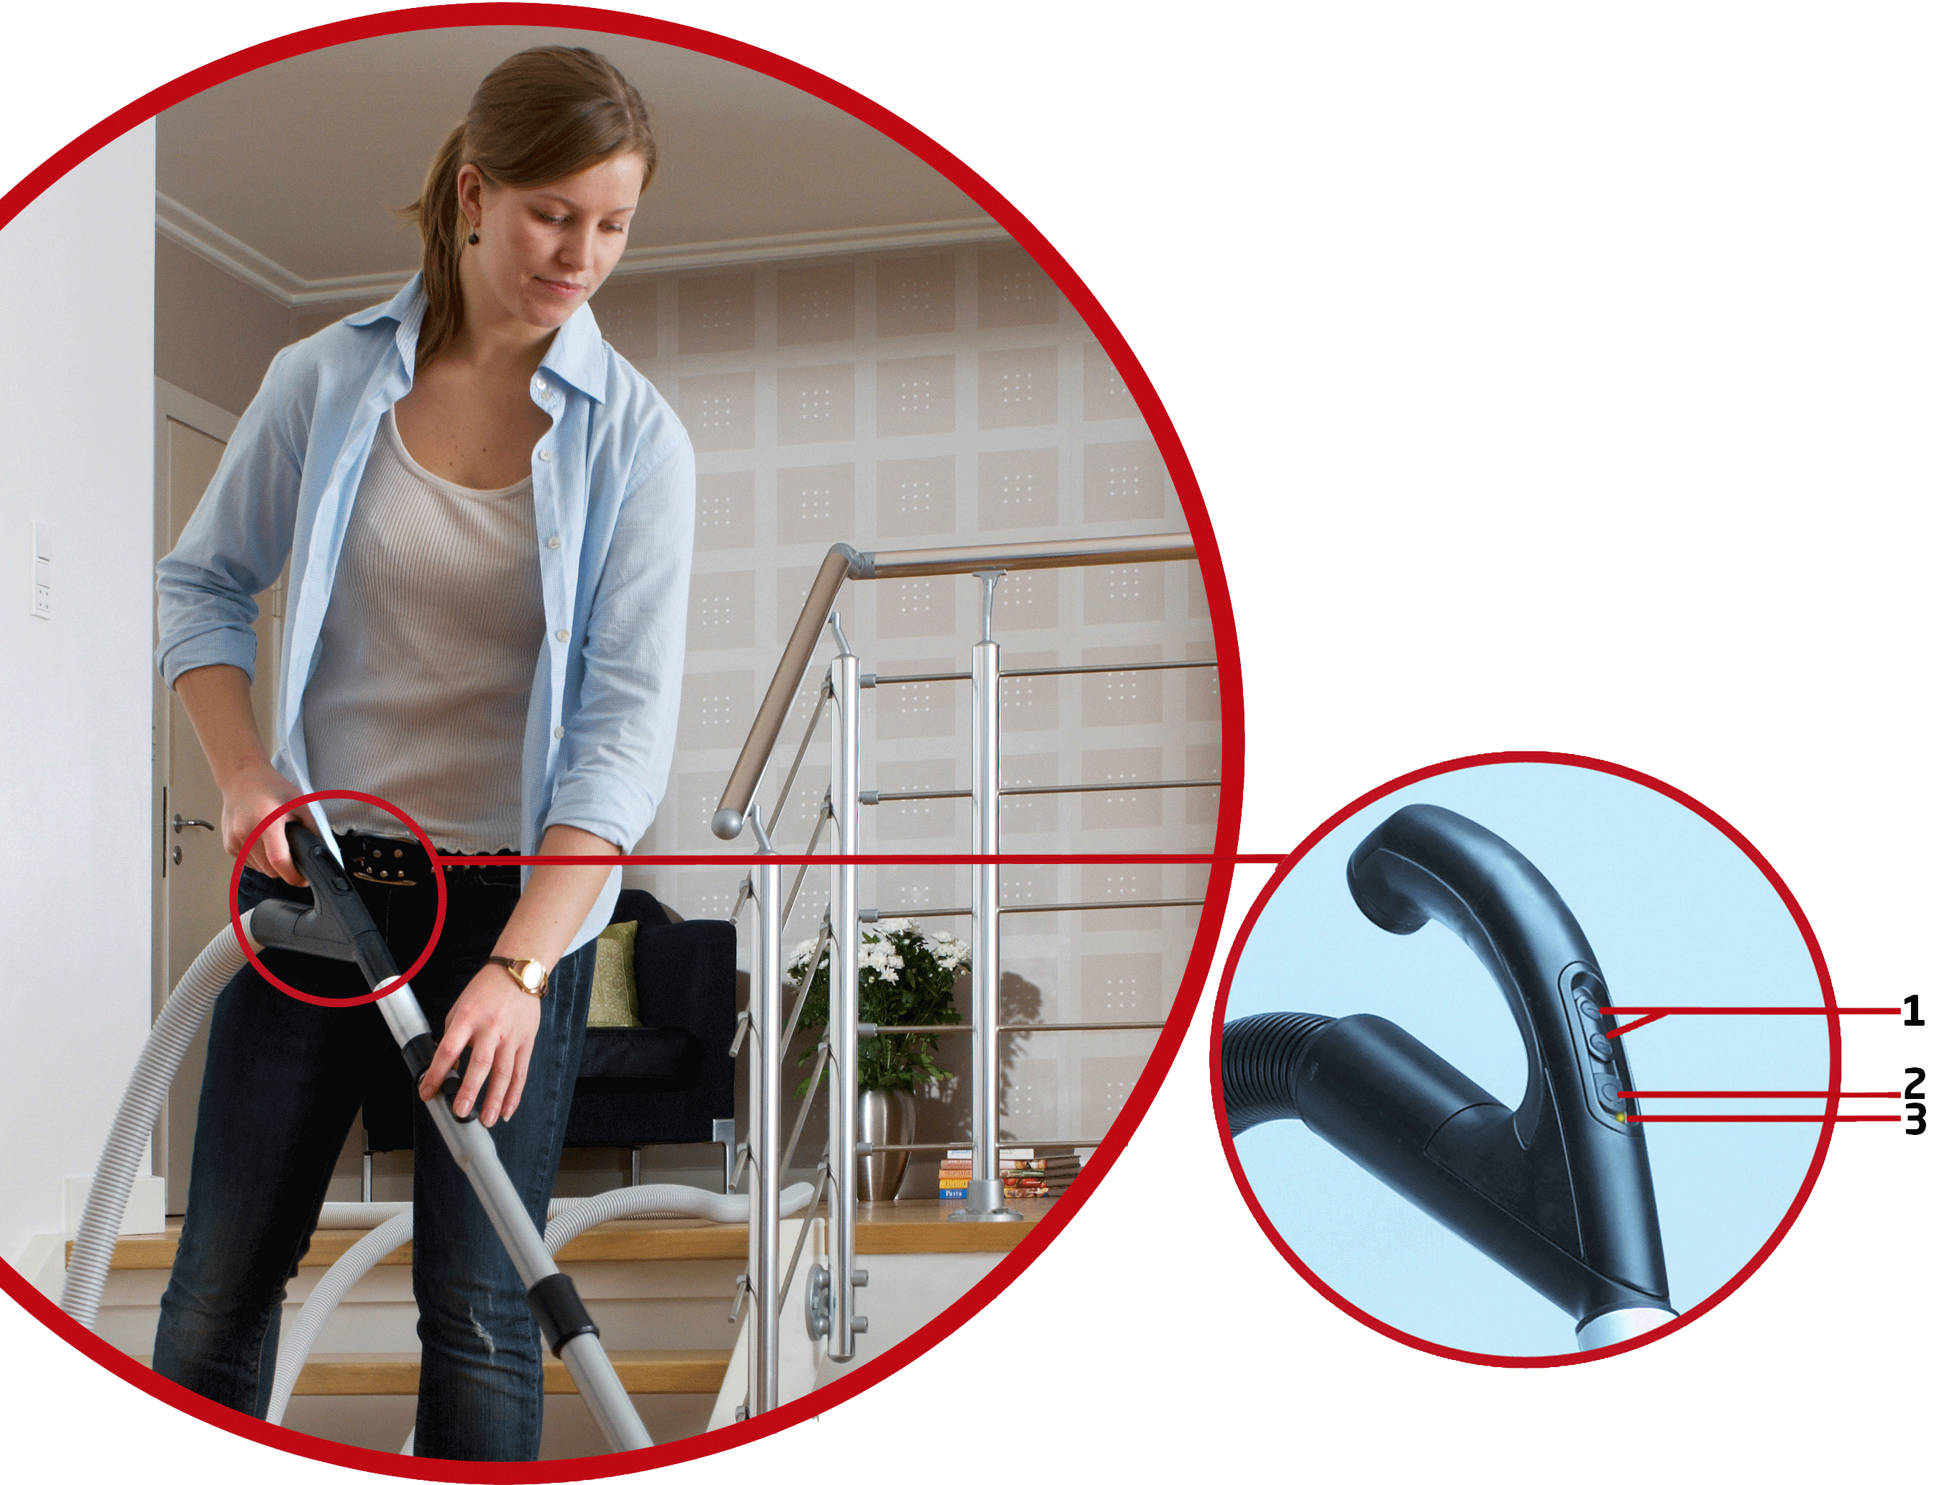

Booklet Template

*A name of quality and reliance for customers*

***INSTALLATION***

*A guide to the installation, use and cleaning process of* ***HENORY*** *vacuum cleaners. Read the instructions carefully and enjoy the best cleaning services of our brand.*

**HENORY VACUUM CLEANERS**

Step 1: ________________________________________________________________________________

Caution: ________________________________________________________________________________

Step 2: ________________________________________________________________________________

Caution: ________________________________________________________________________________

Step 3: ________________________________________________________________________________

Caution: ________________________________________________________________________________

* Vacuum nozzle
* Hose
* Lo120ft long cord
* Dust bag
* Cleaning brushes
* Handheld tools

***ACCESSORIES***

*002-586*

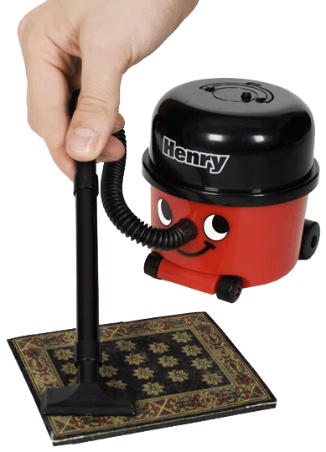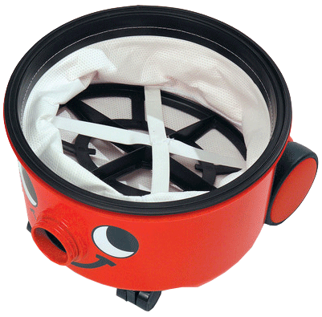

***For more information contact us at:***

**Company Name Here**  
address line 1 address line 2  
phone: 555-555-55555  
fax: 555-555-55555  
www.emailaddress.com

***MAINTENANCE GUIDE***

1. Write here details of instructions to use vacuum cleaner Write here details of instructions to use vacuum cleaner Write here details of instructions to use vacuum cleaner
2. Write here details of instructions to use vacuum cleaner Write here details of instructions to use vacuum cleaner Write here details of instructions to use vacuum cleaner
3. Write here details of instructions to use vacuum cleaner Write here details of instructions to use vacuum cleaner
4. Write here details of instructions to use vacuum cleaner Write here details of instructions to use vacuum cleaner.

***HOW TO USE***

1. Write here details of instructions to use vacuum cleaner Write here details of instructions to use vacuum cleaner Write here details of instructions to use vacuum cleaner
2. Write here details of instructions to use vacuum cleaner Write here details of instructions to use vacuum cleaner Write here details of instructions to use vacuum cleaner
3. Write here details of instructions to use vacuum cleaner Write here details of instructions to use vacuum cleaner
4. Write here details of instructions to use vacuum cleaner Write here details of instructions to use vacuum cleaner